Predictive Policing

Generalitat de Catalunya

**A Quick Overview:**

Catalonia is an autonomous community of Spain. It lies in the northeast of the Iberian Peninsula, to the south of the Pyrenees mountain range. The capital and largest city, Barcelona, is the second-most populated municipality in Spain and the fifth-most populous urban area in the European Union. The Mossos d’Escuadra is police force of Catalonia, responsible for law enforcement in this autonomous area.

**Data Structure:**

In this study, the public data available form the Catalonia police department has been collected, analyzed and evaluated. All the data can be found in the following website:

https://mossos.gencat.cat/ca/els_mossos_desquadra/indicadors_i_qualitat/dades_obertes/

The data used for this study was last updated on the 17/05/2022.

All the data files are provided in two formats: **.csv** and **.json**. Both these formats are used in this analysis.

**Tools Used for Analysis:**

**Section 1:**

Python modules: json, plotly, matplotlib, pandas

Others: Geojson files

**Table of Contents:**

1. **Organizational Information**

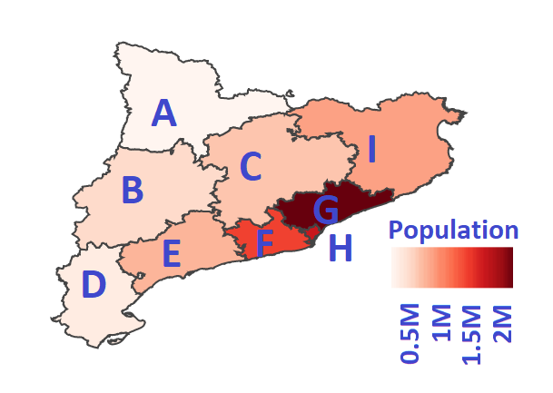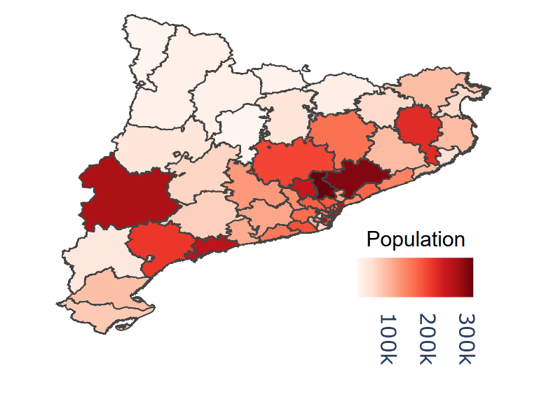Territorially, the Catalan police is divided in 9 regions (Girona, Ponent, Pirineu Occidental, Central, Metropolitana Nord, Barcelona, Metropolitana Sud, Camp de Tarragona i Terres de l'Ebre). Figure 1 (left) shows the geographical location of each of the regions as well as population as of 2022. The **basic police areas** are different divisions of the Catalonia police that are in charge of a specific geographic area and provide the basic police services to the population of that area [1]. Figure 1 (right) shows the territorial division of this basic police areas as well as the population in each one of them.

Figure 1: Left, territorial division of the Catalan police. A: Pirineu, B: Ponent, C: Central, D: Ebre, E: Tarragona, F: Metropolitana Sud, G: Metropolitana Nord, H: Metropolitana Barcelona, I: Girona. Right, Geographical description of the basic police areas in Catalonia.

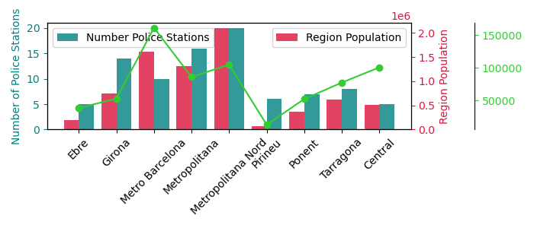 Some of the basic police areas are very complex or have to deal with a big amount of population. For this reason, the **district police stations** provide service to their corresponding basic police area. In [2] one can find the location of the various police offices in Catalunya as well as the necessary contact information. Figure 2 shows for each one of the 9 territorial regions, the amount of police stations and police personal assigned to that region. Not surprisingly a strong correlation exists between amount of population in a territory and number of police officials.

The green line in Figure 2 indicates the average population that lies under the control of a given police station. For example, in the Ebre region, there are 5 police stations. Each of them assigned to an amount of population. The average amount of population that needs to be handled for the police stations in Ebre is around 5000 people per police office. From this we can observe that the police stations in the Metro Barcelona area need to deal in average with a much larger amount of populations.

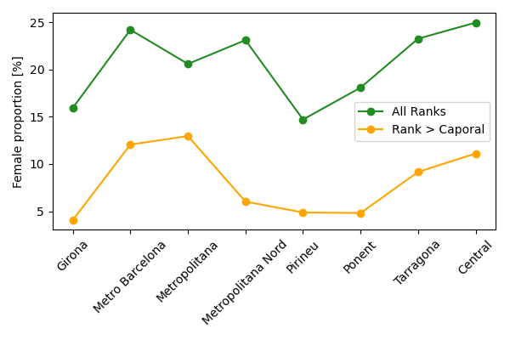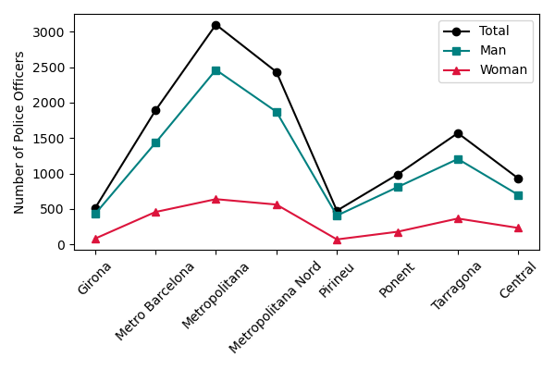If we have a look at the amount of police personnel assigned to each area we can see that the correlation between amount of population and personnel is more even along all the regions. With the police stations in the Metro Barcelona area being some of the largest in Catalunya. This is showed in Figure 3 (left).

The available provided information on the rank of the personnel and the sex. Which allows to do a small gender study of the Catalan police. Figure 3 (right) shows the proportion of female police officers in the various regions. It is not surprising to observe that female officers are a minority, with a maximum of 25% female officers in the Metro Barcelona and Central areas. The female proportion seems to be consistent among the different areas. The proportion however seems to be further diminished when considering higher police ranks. In particular if we consider only ranks superior to Caporal, the maximum proportion of female officers is observed in the Metropolitana area, with a 13%.

BE CAREFUL WITH BARCELONA AND METROPOLITANA!

1. **Criminal Data**
   1. **Evolution of the crimes known by the Catalan Police.**

Figure 4 shows the evolution of known and solved crimes since 2011. The variation of crimes per year seems to fluctuate. We observe a minimum on the crime rates in 2020 and 2021. However, these numbers are evidently influenced by the impacts of the COVID-19 pandemic and should be taken with care.

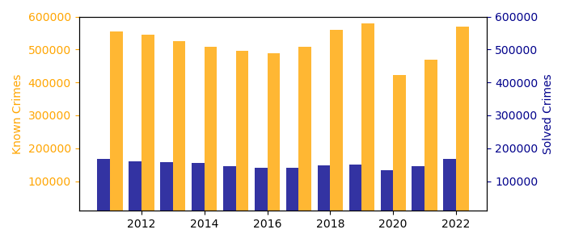

If one compares the solved crimes in 2019 and 2022, we see an overall improvement of a 3.45% in the rate of solved crimes. A comparative evolution of the crime rates in each territorial region is shown in figure 5. In this figure it is shown, in this order, for every region the known crime per number of inhabitants (in 2022), the rate of solved crimes (in 2022) and comparison rates of crimes solved between 2019 and 2022. From this figure we can see that the ratio of criminality per number of habitants is the largest in the Metropolitana Nord and Barcelona areas, which is also where the majority of the population is. The proportion of solved crimes varies between 48.50% in the Pirineus area to 25.77% in the Metropolitan area of Barcelona.

Figure 2 previous figures had told us that the area Metro Barcelona was the area with the most amount of people per police office. However, Figure 3 shows that the total amount of police officers in Metropolitana Barcelona is not as high as in the neighboring areas. This might yield on the lower rate of criminality solved.

In figure 5 we see in red the improvement on the solved cases rate between 2019 and 2022. In all the areas we se ea positive improvement. The metropolitan area of Barcelona being the one with the best improvement rate. This shows how measures have already been put into place to solve the situation in this area.

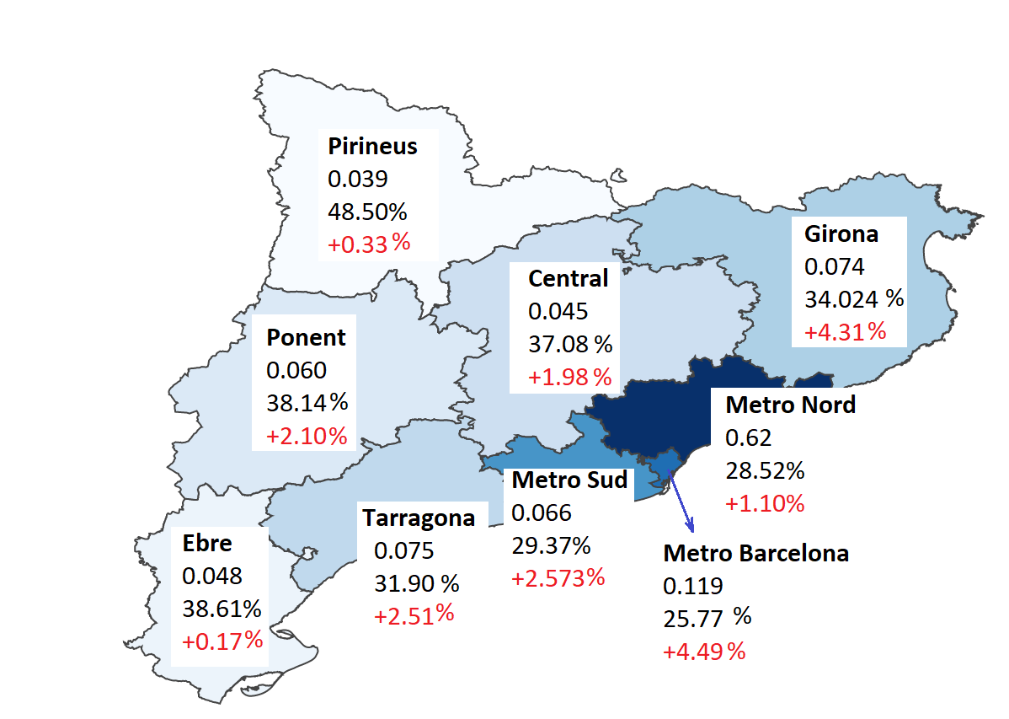

**2.2 Types of crimes in Catalunya.**

The types of criminal acts in Catalonia are classified in the following way:

Total Number of Crimes

Robbery

Burglary

Thefts

Harm

Scams

Others

Police Resistance

Against public health

Drunk driving/drugs

Other driving crimes

Public disorder

Criminal groups

Others

Others

Murder

Murder Attempt

Sexual Assault

Other sexual crimes

Injuries

Home violence

Threats

Coercion

Others

Murder

Murder Attempt

Sexual Assault

Other sexual crimes

Injuries

Home violence

Threats

Coercion

Others

Crimes against Property

Crimes against People

2.2

**2.2 Domestic and Gender violence.**

* 1. **Mobility and Public transport crimes.**

1. **Police Activity and Prevention.**

**Conclusions**

References

[1] <https://ca.wikipedia.org/wiki/%C3%80rea_B%C3%A0sica_Policial>

[2] <https://mossos.gencat.cat/.content/home/dadesobertes/comissaries/index.html?lang=en>